**NAME**

**COLLEGE NUMBER**

**Introduction**

This is a mock-up of the Derby app with both the home screen page and the team page showing match ids and their match timetable for the given match days. I have used a number of UI components to achieve some of the visualisation functions that are needed for each of the pages. Buttons have been used to create actionable clicks on the app, text inputs have been used to prompt user to enter certain pieces information that will require a given step to be achieved. Labels have been used to highlight specific information about given actions that are intended for user actions.

The app is intended to be dynamic and user interactive. This has been achieved by enabling the user to register and login to the app. For a user to select and view teams and matches, they have to login using their phone number and password associated with that account. The app has also utilized icons from the Google material UI, two of these icons such as the chat icon and the notifications icon, in the final app, the chat icon is intended to enable the users to chat with each other or with support team.

The notifications icon will enable the user to receive app specific notifications on when a match is supposed to be played or any changes that have been done and made by user. The app is broken down into various pages that developers can now convert into code. The homepage has the leagues which contain the teams and fixtures, under each team are players, then from the player we the player profile. The 4 entities above are linked and related with primary keys for each entity.

The design has been done using Fluidui found at <https://www.fluidui.com/editor/live/>

The flow is as below:

1. **Homepage – With Leagues**

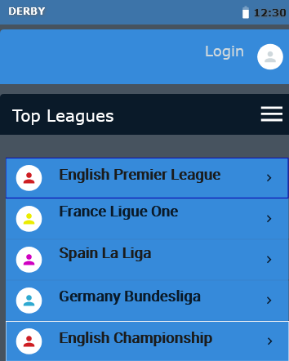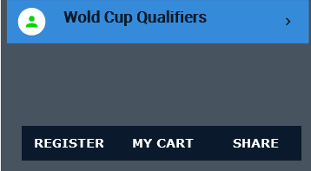

1. **Teams and Fixtures**

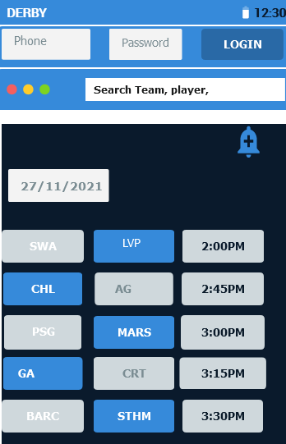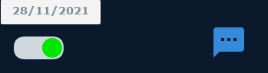

1. **Team players**

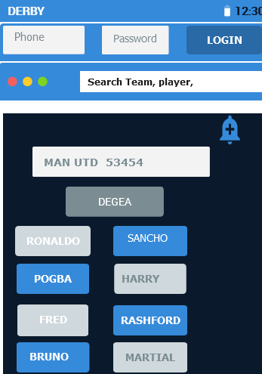

1. **Player profile**

